

**Hamza YAVUZ**

**17030411056**

**MIS**

**Operations Management Project**

**‘Sultan's Local Products Shop’**

**Sultan's Local Products Shop**

The Sultan's Local Products Shop sells in Ankara. Local products are sold in this establishment such as village bread, pancake, dough. The number of employees varies because it is a family business. The owner of the firm also deals with other departments, as other members of the family work in different jobs.

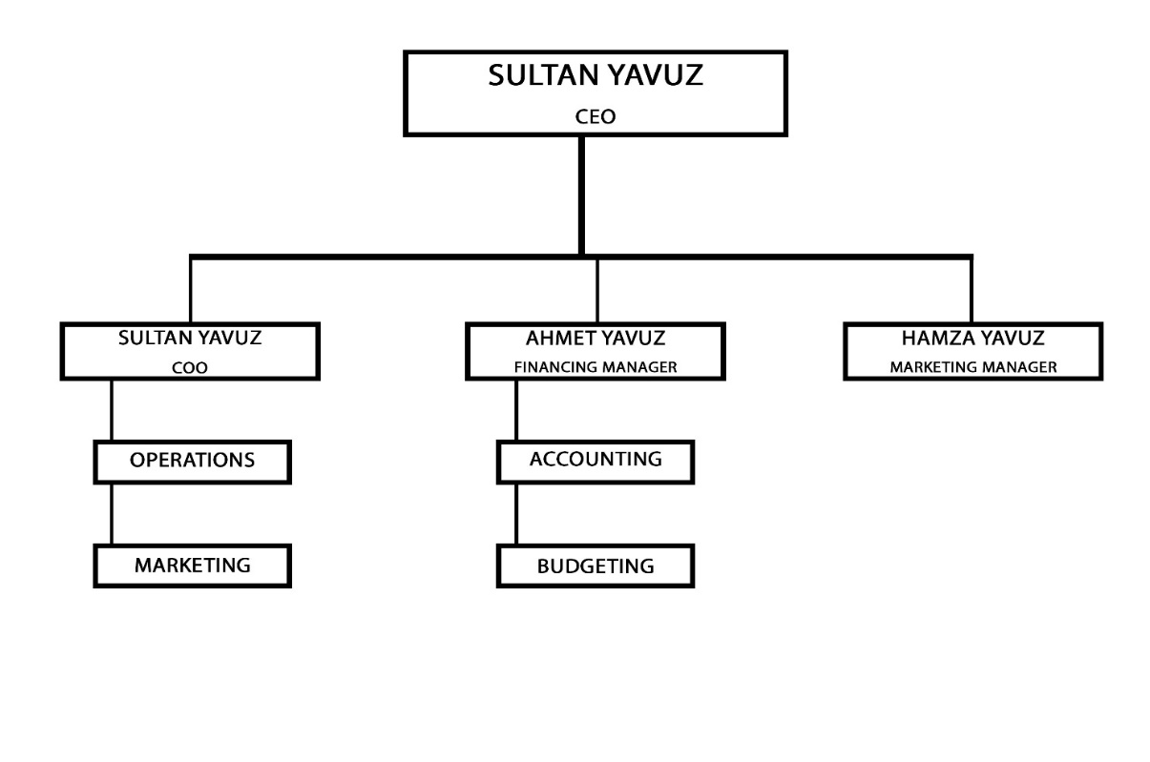

**Sultan YAVUZ** (owner-general manager): The main owner of the company. It also has the roles of an employee and general manager. The company orders the products daily, weekly and monthly. Phyllo dough comes daily, and a different kind of phyllo dough comes once a week. Since these products should be daily and fresh, they are determined daily by the company owner. It also deals with product and stock management.

Flours are ordered monthly for the company. When ordering the flour, they make a joint decision with the finance manager because the income keeps the finance manager.

**Hamza YAVUZ** (marketing manager – clerk): I am dealing with both advertising and marketing business and salesmanship in the company. I am designing posters to attract people's attention. I share products on social media because social media is very important nowadays.

While working in the company, I also work as a shop assistant. I take people's orders and pass them on to employees.

**Ahmet YAVUZ** (Financing Manager): It tracks the daily and monthly income and expenses of the company. It deals with the investments that the company has to make at the end of the month. It makes a table about how many flour the company should buy monthly. It updates prices by comparing prices with competitors. It prepares a monthly profit and loss statement.

Pancakes and village bread are produced as local products in the store. These products are made daily. In addition to these products, products such as tarhana, noodles and ravioli are also produced and sold.

Village bread starts at 5 am because it is very laborious and takes a long time to make. How much will be produced is determined by the analysis of the previous days. If business had been stagnant in the previous days, the amount of village bread would have been produced less, if things were good, the amount would increase. Pancake production is made according to the customer order. Pancake batter is always ready. It is made and delivered within 10 minutes when the customer requests.

Since noodles dry naturally, they should be cut 1 week before they go on sale. 10 kg of noodles are cut once or twice a week.

Manti is frozen so that it does not spoil. For this reason, ravioli should be made 1 day before going on sale.

We can prepare and store a few portions so that the customer does not wait. This also speeds things up. The customer can be served by putting tables inside and outside.

**Key Factors**: Although people want to live a modern life, local products have an important place for them. Because they remember their past with local produce. Local products also consist of naturally produced products. Although it is fast food, it is preferred because it is healthy. Since it is a store run by my family, I wanted to explore how I could improve it by selecting and analyzing this store.

**Mission**: We are working to make it easier for people to reach local products. You can buy your local products from our company without going to the village.

**Vission**: We want to produce products combined with local and traditional products. We plan to make our sales on different platforms in order to reach more people.

**Goal**: We plan to increase the company's sales revenues and monthly profit. We plan to have more customers.

Objectives: We are planning to attract people's attention with different types of noodles. We are trying to attract people's attention by baking village bread in different sizes.

**Process Flow Diagram:**

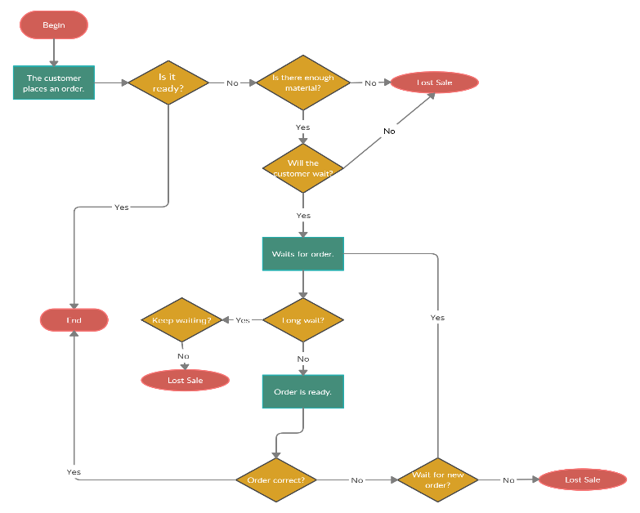

When a customer comes to the company, if his product is ready, we can deliver his order immediately. However, if the product is not ready and the customer can wait, we can receive the customer's order. If we have materials to make the product the customer wants, we start making the product. We finish and deliver the order.

When we deliver the order, if we realize that we made the wrong product, we ask the customer "can you wait". If he does not want to wait, the order is canceled. If he waits, we complete his order and deliver it.

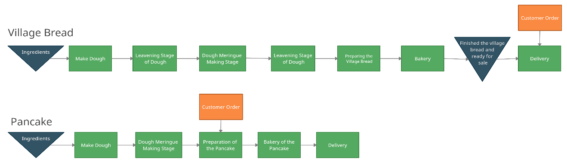

Village bread must be prepared in advance as it has to wait a very long time. In the first stage, the dough is kneaded and put on hold. In the next step, the dough is turned into meringue and put on hold again. After waiting for a while, it is given to the oven and made ready to order. These processes take approximately 5 hours.

The pancake dough is kneaded. After kneading the pancake dough, it is turned into meringue. Orders are taken according to the customer and the materials we have. The order is delivered as soon as possible.

**İnformation Flow Diagram:**

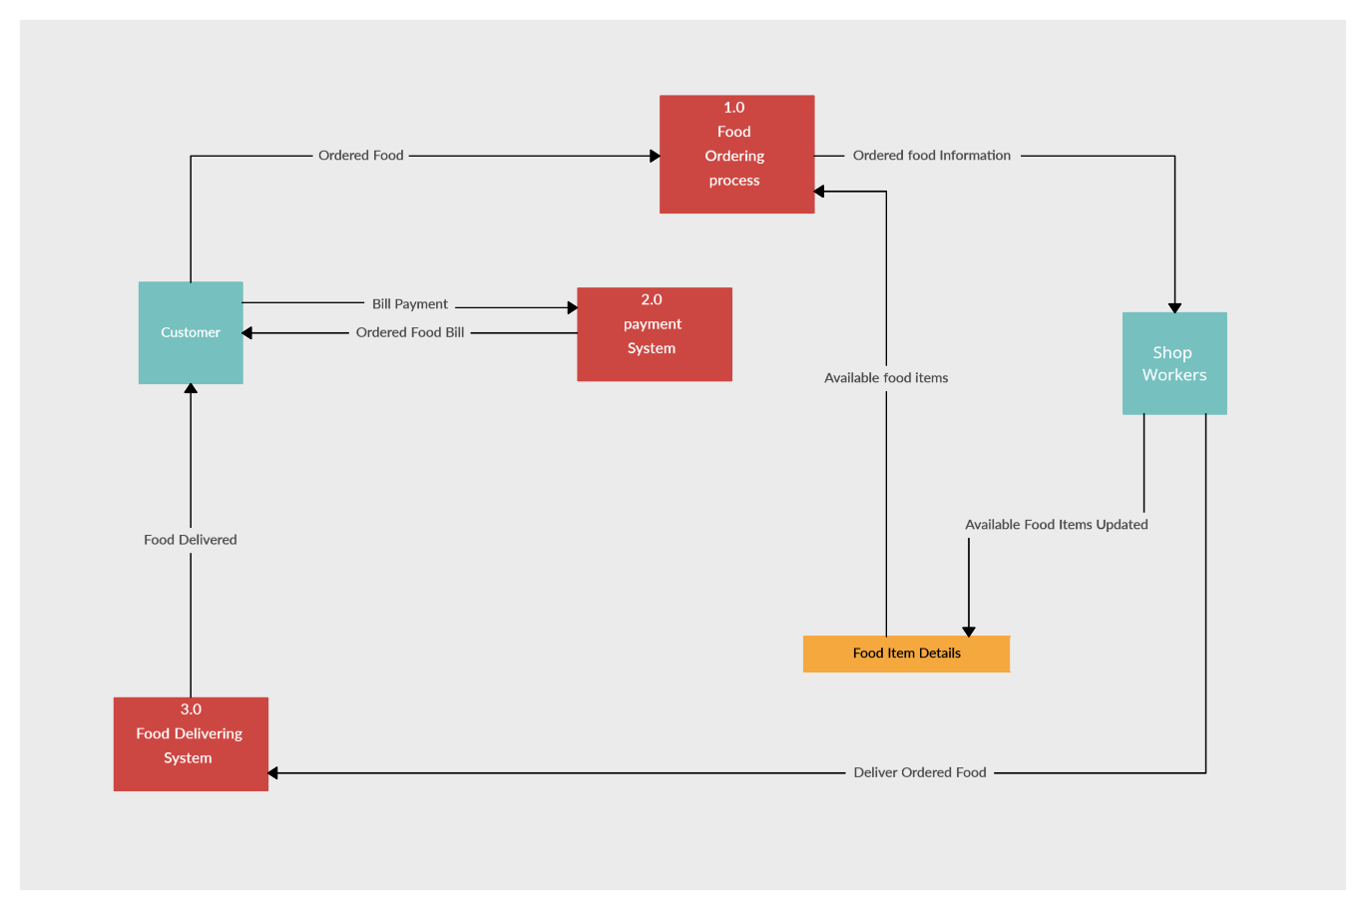

The customer places his order. After receiving the customer's order from the store, we inform the employees. If there is enough material, we prepare the customer's order. If there is not enough material, we will inform the customer. After receiving the payment from the customer, we cut the receipt and deliver the order.

**Second Part**

There are so many problems in the store that need to be improved and solved. These are mainly for increasing the product variety and quality, selling on e-commerce sites or different platforms, bringing the company's daily meals (pancake, village bread, etc.), taking and solving orders from platforms such as yemeksepeti, location issue.

***1. Product variety and quality***

There are limited products in the company. Product variety can be increased. While increasing the product variety, the target audience should be different. For example, vegetable noodles can be produced for families with small children. Thus, families find a different solution for their children who do not like vegetables. At the same time, the variety of products in the store is increasing as these noodles are easy to store and dry.

There are not many products in the shop from the villages. We can focus on products such as village milk, village eggs, village cheese obtained from the village. However, when these products arrive, there may be a storage problem as these products must be stored in the refrigerator. This problem can be solved by bringing the products with order.

We can increase the variety of products we put into the pancake. For example, products such as sausage and minced meat can be added, but this may increase the cost. As the cost increases, we can increase the sales price and get the cost from the customer.

The quality of the products in the store can be improved, but this can also affect the cost increase. Higher quality products can be obtained by changing the raw material of the village bread made.

***2. Making sales and taking orders from e-commerce sites***

Since the pandemic period, people have completely closed to homes and started using e-commerce companies for shopping. To increase the profit and sales of the store, we can apply to e-commerce companies and sell online. Products that will not be stale even if they wait for a long time on some sites; Products that need to be consumed on the same day can be sold on some sites. Non-perishable products can be sent to all parts of the country by cargo, but perishable products can only be sent to people nearby by courier.

Noodles, ravioli and different local products can be sold as non-perishable products in e-commerce companies. Products to be delivered by order and courier on the same day may be flatbread and village bread. Some sites may need to provide our own courier, but some sites may also provide a courier service. For example, we have to provide the courier in Yemeksepeti, but in Getiryemek provides its own courier. Therefore, there may be a difference in commission fees here. When selling on sites, we have to reflect the commission fee to the customer. Otherwise, the shop will not profit.

***3.Location Problem***

The location of the shop poses a problem in many ways. The main problems are the large number of different shops for local competition and the few customers of the street where it is located. When you look at the district where the shop is located, there are many local product shops. Since some of these were opened before this shop, people may prefer old opened shops. The good location of other stores also reduces the work of our store. People only use the street where the shop is located as a road. They do not prefer the street for shopping. This causes the shop's profit to be low. It needs to be moved directly to a different location to fix the problem.

Looking at the neighborhood, people do not prefer to buy local products from outside. Generally, women prefer to produce these products at home because they are not working. Since working women do not have time to do these jobs, they prefer to buy products from a reliable place. For this reason, the district where the shop is located should be changed.